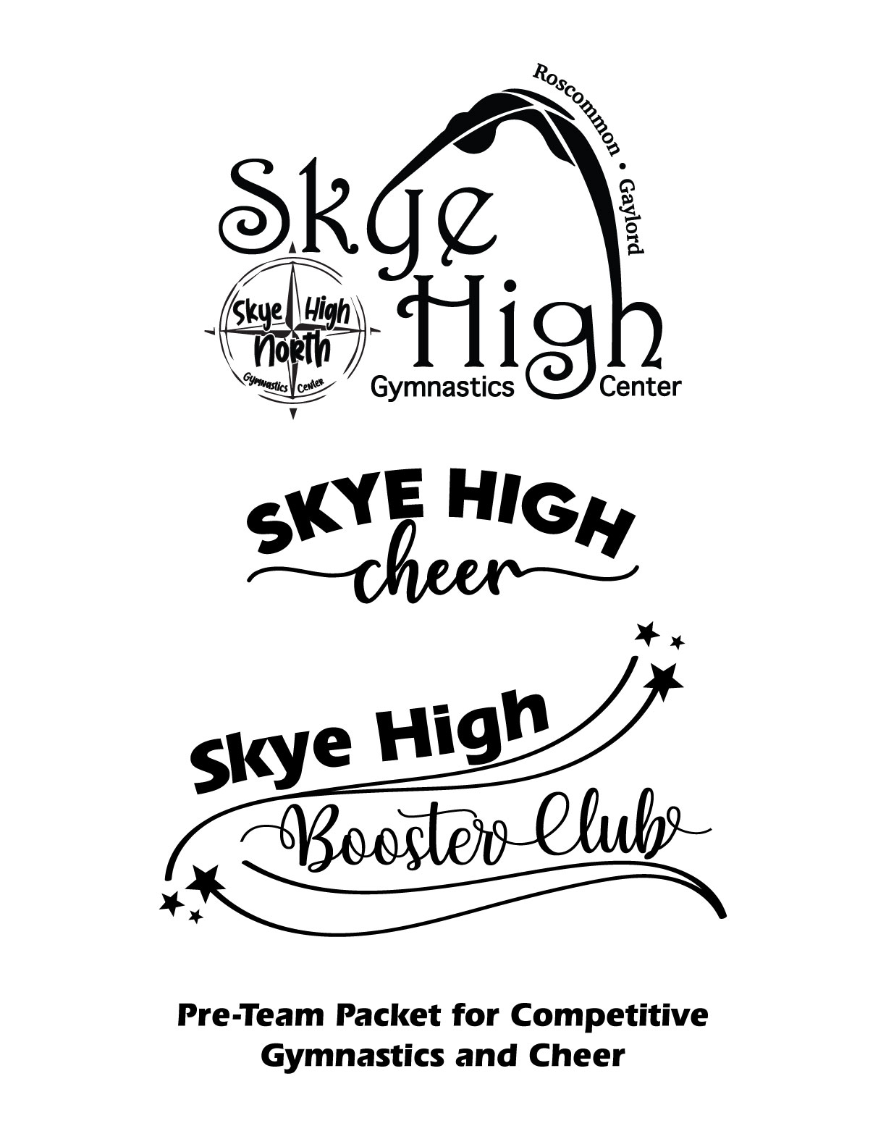
Pre-Team Gymnastics at Skye High!
Pre-team gymnastics will begin after Christmas break and is required if you are interested in joining the team for the 2022-2023 season. Pre-team class is $25 in addition to your usual recreational class.
Wednesdays 7:00-8:00 in both locations. If you wish to register, please email at shgc.office@gmail.com.

Competitive Gymnastics Information

Skye High Gymnastics Center competes as a part of the Xcel Gymnastics Program.
Xcel is an alternative USA Gymnastics competitive program offering individual flexibility to coaches and gymnasts. The goal of Xcel is to provide gymnasts of varying abilities and commitment levels the opportunity for a rewarding gymnastics experience.
Levels: Xcel - Bronze, Silver, Gold, Platinum, Diamond
*Gaylord Levels higher than bronze/silver will need to transfer to our Roscommon location.

Schedules are subject to change, but here’s what you can expect for the class schedule for 2022-2023.
Gaylord Bronze/Silver: TR 4:30-6:30 Roscommon Bronze/Silver: MW 4:30-7:00
Gold: MW 4:30-8:00 F 4:30-7:00 Platinum/Diamond: MW 4:30-8:00 RF 6:30-8:00
Costs for Team:

Attire: Due August 1st
- $150.00 for Team Leotard (new leotard every two years)
- $150.00 for Team Warm-ups (made to last as long as possible)
- $80.00 for Team Back Pack (made to last as long as possible)
Level | Monthly Tuition
Bronze | $130/month (2 days/week)
Silver | $130/month (2 days/week)
Gold | $150/month (3 days/week)
Plat/Diamond | $170/month (4 days/week)
Tuition: This can be broken down into the following:
- Seasonal payments: June-Aug, Sept-Dec, Jan-May – 5% off
- Double season payments: Sept-May – 10% off
- Year payment: June-May – 15% off
- Monthly payments: no discount
**If you wish to average your fees into your tuition payments, please let us know.

Competitions: $200 per competition – due 2 months before competition (See Booster Club Handbook Attached)
- In-house competitions (mock meet): 1 per year
- USAG Sanctioned Meets: Bronze/Silver – 3 | Gold – 4 | Platinum/Diamond – 5
- State & Regional Meets are dependent on qualification

Miscellaneous: These fees will be posted to accounts as needed.
- $50.00 for bar grips (required for Gold + levels – due first summer class.)
- $61.00 USA Gymnastics Registration Fee (All Team Members - Due Aug 1st - Paid directly to USAG)
- Choreography fees (Bronze/silver: $40, gold, platinum, diamond $65 – end of summer)
- Team photos (not required)
- Team shirts (not required)
- Cost of travel for competitions

There will be various fundraisers throughout the year! Please talk to us if you have questions about fees and tuition! We have a booster club (Skye High Booster Club) and scholarship opportunities available.
Students are required to come to every class. Absences may result in your child being pulled from a competition.
Pre-Team Cheer at Skye High!
This program will give your athletes the opportunity to travel and present their skills in front of judges and compete against other teams! Joining pre-team cheer is NOT a binding contract to compete in the fall. It is designed to give your athletes an opportunity to decide if they enjoy cheer to compete before joining the team. This decision MUST be made by August 1st.

If you wish to register for pre-team cheer, please email at shgc.office@gmail.com.

Pre-team classes are $25 per month. Classes will begin the first week of January. Roscommon classes are Mondays from 7:00-7:45 and Gaylord classes are Thursdays from 5:00-5:45 from January to May.

Cheer Team Information

Attire:
- Cheer Uniform – due August 1st
  - Top - $65, Skirt - $50, Spanks - $10, Bow - $10
  - Shoes are to be purchased by parents (all white cheer shoe)
- Warm-Up Top – due September 1st - $50
  - Black sweat pants are to be purchased by parents

Tuition:
- One class per week - $45/month
- As levels increase, time in the gym may increase as well.
- It is highly recommended to take gymnastics in addition to cheer.
- Summer practice is REQUIRED! Any athlete coming into team without participating in summer practice will have to schedule and pay for an individual try-out with head coach - $40.

Competitions:
- Competitions are $110 per competition – due dates are 2 months before each competition (See Booster Club Handbook Attached)
- Cheer teams will attend 3-4 competitions per year.

There will be various fundraisers throughout the year! Please talk to us if you have questions about fees and tuition! We have a booster club (Skye High Booster Club) and scholarship opportunities available.
Students are required to come to every class. Absences may result in your child being pulled from a competition.

Skye High Booster Club

Our Mission:

The sole objective of the Booster Club is to serve as a source of encouragement and financial support for the Skye High Gymnastics Center competitive teams (Cheer & Gymnastics). Primarily through fees, fundraising, and donations, the Booster Club offers opportunities to athletes to pay all scheduled individual and team fees. In addition, it provides monies for coaches’ expenses incurred during meets, assist in recital, fun meet, banquet or picnic expenses and awards.

Booster Club information:

Booster Club will work to provide a new fundraiser opportunity (as applicable) for athletes to participate in. We will also maintain an online website for apparel orders that will allow for general fundraising funds. (This will not be specific to any one athlete and currently will not be eligible for credit to tuition or competition fees.)

All recreational class athletes will be eligible to earn credit each season towards tuition based on fundraising efforts. Amount and details may change season to season based on fundraising efforts for all athletes.

All competition athletes will be eligible to earn a credit towards coemption meet fees based on fundraising efforts. Amount and details may change season to season based on fundraising efforts for all athletes.

**Fundraising will be imperative to the success of the booster club and its mission. We ask that all families participate to the best of their ability to continue to assist in the growth of not only the booster club, but all the programs offered by Skye High Gymnastics Center. (Booster club is working towards taking over the low income and scholarship financial obligations from Skye High Gymnastics Center.)

Booster Club Needs:

Volunteers! We desperately need volunteers to step up and assist in the startup and future growth of the Booster Club. We are in the final stages of approval for nonprofit 501c3 status. This allows us to be tax exempt and take donations directly from businesses with tax write off option and apply for local grant opportunities to continue the growth of Skye High Gymnastics Center Programs here in Northern Michigan.

Due to the young age of the booster club and being in the beginning startup phase, some things may change over time, but the mission will remain the same!

Contact Us:

If interested, have questions, comments, or concerns please feel free to reach out via email: skyehighboosterclub@gmail.com or call/text: 989.745.4445

